|  |  |  |
| --- | --- | --- |
| 編號 |  | 收件者 |
| 收件日期 |  |

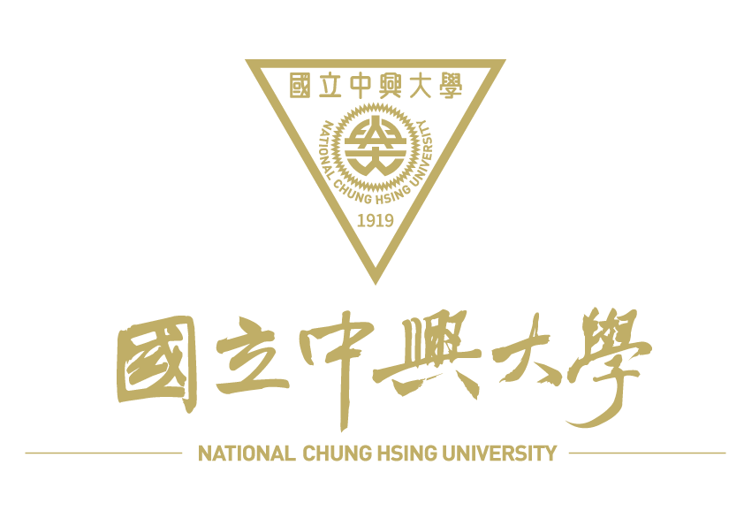**質譜分析服務申請表MS Service Request Form**

**申請者資料Client Information**

|  |  |  |  |  |  |
| --- | --- | --- | --- | --- | --- |
| 實驗室主持人PI name |  | | 實驗室主持人簽章PI signature | |  |
| 單位名稱Dept |  | | 申請日期Date | |  |
| 聯絡人Contact Name |  | | 聯絡電話 Tel | | ( ) |
| E-mail |  | | 校內計畫編號(收據)/ 統一編號(發票) | |  |
| 發票郵寄地址Address： | | | | | |
| 服務項目(使用儀器) Service item | | | 樣品數量(個) sample amount | 校內單價(元) Price per sample (NTD, on-campus) | 校外單價 (元/未稅)  Price per sample (NTD, before tax, off-campus) | | |
| 1. 胜肽或蛋白質分子量測定Peptide/protein mass analysis (MALDI–TOF) | | |  | 800 | 1,500 | | |
| 1. 蛋白質身分鑑定Protein identification I (MALDI – TOF) | | |  | 1,000 | 2,000 | | |
| 1. 蛋白質身分鑑定Protein identification II (LC/MS/MS) | | |  | 2,000 | 3,000 | | |
| 1. 小分子化合物鑑定/定量Small molecule identification/quantification (LC/MS/MS) | | |  | 2,000 | 3,000 | | |
| 1. 全蛋白體鑑定分析Total Protein identification (LC/MS/MS) | | |  | 9,000 | 12,000 | | |
| 1. 揮發性化合物鑑定Volatile Compound analysis (GC-MS) | | |  | 2,000 | 3,000 | | |
| 【大量送件優惠】 單次送件樣品數≧10個95折優惠，≧20個9折優惠，≧30個85折優惠，≧50個8折優惠。Preferential Price for Large Sample Numbers: ≧ 10 samples get 5% off, ≧ 20 samples get 10% off, ≧ 30 samples get 15% off, ≧ 50 samples get 20% off | | | | | | | |

**樣品特性敘述Sample information**

|  |  |  |  |  |  |
| --- | --- | --- | --- | --- | --- |
| 樣品名稱或代碼 Sample name |  | | | 所屬物種 Taxonomy (genus/species) |  |
| 樣品狀態sample status： □ 固態粉末 Powder □ 水溶液 Solution □ 膠體 Gel | | | | | |
| 1. 種類sample type --- □ protein □ peptide  2. 染色方式stain method  3. 估計分子量approximate mass kDa，估計方式estimate method  4. 蛋白質含量protein content pmol (g)，測定方法determination method  5. 蛋白質純度protein purity ％，測定方法determination method  6. PI 值isoelectric point ，可能修飾基variable modification | | | | | |
| 固態粉末樣品 是否含鹽類salt containing? □ No □Yes  Powder sample 主要鹽類種類main salt ， mM | | | | | |
| 水溶液樣品 主要溶劑種類main solvent A ， %  Solution sample B ， %  是否含鹽類salt containing? □ No □ Yes  主要鹽類種類main salt ， mM  (※請列出全部種類please list all ingredients) | | | | | |
| 樣品儲存Sample Storage | | □-20℃(defult) □4℃ □室溫 □其他other: | | | |
| 是否附有圖譜Gel photograph | | □ No □ Yes | | | |
| **申請者備註 Other information about sample** (請詳述任何有助於分析的資料) | | |  | | |

* 本實驗室不接受放射性樣品及毒性樣品 We do not accept radioactive samples and toxic samples.
* 請盡量降低鹽類含量，尤其不可含有磷酸鹽和清潔劑。樣品請保存於水或0.1％ formic acid內。Please try to reduce the salt content, especially the phosphate and detergent. Please store the sample in water or 0.1％ formic acid.

|  |  |  |  |  |  |
| --- | --- | --- | --- | --- | --- |
| 個人資料提供同意書 | | | | | |
| 文件編號 | NCHU-PIMS-D-013 | 機密等級 | 內部使用 | 版次 | 1.0 |

本同意書說明國立中興大學（以下簡稱本校）將如何處理本表單所蒐集到的個人資料。

當您勾選「我同意」並簽署本同意書時，表示您已閱讀、瞭解並同意接受本同意書之所有內容及其後修改變更規定。若您未滿二十歲，應於您的法定代理人閱讀、瞭解並同意本同意書之所有內容及其後修改變更規定後，方得使用本服務，但若您已接受本服務，視為您已取得法定代理人之同意，並遵守以下所有規範。

1. **基本資料之蒐集、更新及保管**

1. 本校蒐集您的個人資料在中華民國「個人資料保護法」與相關法令之規範下，依據本校【隱私

權政策聲明】，蒐集、處理及利用您的個人資料。

2. 請於申請時提供您本人正確、最新及完整的個人資料。

3. 本校因執行業務所蒐集您的個人資料包括姓名、聯絡方式(電話、E-Mail、聯絡地址)等。

4. 若您的個人資料有任何異動，請主動向本校申請更正，使其保持正確、最新及完整。

5. 若您提供錯誤、不實、過時或不完整或具誤導性的資料，您將損失相關權益。

6. 您可依中華民國「個人資料保護法」，就您的個人資料行使以下權利：

1. 請求查詢或閱覽。(2)製給複製本。(3) 請求補充或更正。(4) 請求停止蒐集、處理及利用

(5) 請求刪求。

但因本校執行職務或業務所必須者，本校得拒絕之。若您欲執行上述權利時，請參考本校【隱私權政策聲明】之個人資料保護聯絡窗口聯絡方式與本校連繫。但因您行使上述權利，而導致權益受損時，本校將不負相關賠償責任。

1. **蒐集個人資料之目的**

1. 本校為質譜分析服務業務需蒐集您的個人資料。

2. 當您的個人資料使用方式與當初本校蒐集的目的不同時，我們會在使用前先徵求您的書面同

意，您可以拒絕向本校提供個人資料，但您可能因此喪失您的權益。

3. 本校利用您的個人資料期間為即日起1年內，利用地區為台灣地區。

1. **基本資料之保密**

您的個人資料受到本校【隱私權政策聲明】之保護及規範。本校如違反「個人資料保護法」規定或因天災、事變或其他不可抗力所致者，致您的個人資料被竊取、洩漏、竄改、遭其他侵害者，本校將於查明後以電話、信函、電子郵件或網站公告等方法，擇適當方式通知您。

1. **同意書之效力**

1. 當您勾選「我同意」並簽署本同意書時，即表示您已閱讀、瞭解並同意本同意書之所有內容，

您如違反下列條款時，本校得隨時終止對您所提供之所有權益或服務。

2. 本校保留隨時修改本同意書規範之權利，本校將於修改規範時，於本校網頁(站)公告修改之事

實，不另作個別通知。如果您不同意修改的內容，請勿繼續接受本服務。否則將視為您已同意

並接受本同意書該等增訂或修改內容之拘束。

3. 您自本同意書取得的任何建議或資訊，無論是書面或口頭形式，除非本同意書條款有明確規定，

均不構成本同意條款以外之任何保證。

1. **準據法與管轄法院**

本同意書之解釋與適用，以及本同意書有關之爭議，均應依照中華民國法律予以處理，並以臺灣臺中地方法院為管轄法院。

* **我已閱讀並接受上述同意書內容   
   當事人簽名 (請親簽) 年 月 日**

|  |  |  |  |  |  |
| --- | --- | --- | --- | --- | --- |
| Consent to Provide Personal Data | | | | | |
| 文件編號 | NCHU-PIMS-D-013 | 機密等級 | 內部使用 | 版次 | 1.1 |

This consent letter (this "Consent") sets forth how National Chung Hsing University ("NCHU") will process the personal data collected hereunder.

By ticking the "I agree" box and signing this Consent, you confirm that you have reviewed and understand and agree to the terms of this Consent and its amendments. If you are under the age of 20, you cannot use the service until your legal guardian has reviewed and understands and agrees to the terms of this Consent and its amendments. Nevertheless, you will be deemed to have obtained your legal guardian's consent and agreed to comply with the following terms if you have used the service

1. **Collection, Updating, and Custody of Personal Data**
2. NCHU will collect, process, and use your personal data in accordance with the Personal Data Protection Act and other relevant laws and regulations as well as NCHU's Privacy Policy.
3. Please provide your correct, updated, and complete personal data in the application.
4. Your personal data that NCHU collects during the course of business includes your name and contact information (telephone number and e-mail address).
5. To ensure the correctness, accuracy, and completeness of your personal data, please report to NCHU any changes in your personal data.
6. Your rights and/or interests may be jeopardized if you provide NCHU with false, untrue, outdated, partial, or misleading personal data.
7. You may exercise the following rights as regards your personal data in accordance with the Personal Data Protection Act: (i) inquire into or review your personal data; (ii) ask for duplicates of your personal data; (iii) ask to supplement or correct your personal data; (iv) ask to stop collecting, processing and/or using your personal data; and (v) ask to delete your personal data.

NCHU may refuse your request(s) in order to perform its duties or conduct its business. If you would like to exercise the foregoing rights, please refer to NCHU's Privacy Policy to find out NCHU's liaison in charge of personal data protection and contact methods. NCHU will not compensate any loss or damage you may sustain from the exercise of such rights.

1. **Purposes of Collecting Personal Data**
2. NCHU will collect your personal data for the application of mass spectrometry analysis service.
3. NCHU will seek your prior written consent if and when your personal data is to be used for any purpose other than that for which NCHU collected your personal data. You may refuse to provide your personal data, but you may lose your rights and/or interests accordingly.

(3) NCHU may use your personal data in Taiwan for a period of one years commencing from now on the date of submitting your application (subject to change as needed).

1. **Protection of Personal Data**

Your personal data is protected by and under NCHU's Privacy Policy. Please review the Privacy Policy for its full text. If NCHU violates the Personal Data Protection Act or your personal data is stolen, divulged, modified, or damaged owing to any natural disasters, extraordinary event or circumstance beyond its control, NCHU will notify you by telephone, mail or e-mail, or post the notification on its website, whichever NCHU deems appropriate, after conducting necessary investigations.

1. **Effect of Consent**
2. By ticking the "I agree" box and signing this Consent, you confirm that you have reviewed and understand and agree to all the terms of this Consent.
3. NCHU reserves the right to amend this Consent at any time. NCHU will post the amendments on its website and will not send a separate notification to you. Do not keep using the service if you object to the amendments. If you continue using the service, you will be deemed to have agreed to be bound by the amendments.

(3) Unless otherwise explicitly provided in this Consent, no suggestion or information that you may obtain in connection with this Consent, whether in writing or orally, shall constitute a commitment in addition to this Consent.

1. **Governing Law and Jurisdiction**

This Consent shall be construed and interpreted in accordance with the laws of the Republic of China. Any dispute arising from this Consent shall be governed by the laws of the Republic of China and heard by the Taiwan Taichung District Court. 

* I have reviewed and accept the terms of this Consent

Signature________________(please sign your name) Date: _____________________